Digital Construction

15/01/2024

Michael Mcguire WorldSkills UK
wsukbim@nclan.ac.uk

We thank all the amazing sponsors that make this competition possible:

Competition Overview

Building Information Modelling (BIM) is the process that provides the tools to more effectively and efficiently plan, design, construct and manage buildings and infrastructure. The WorldSkills UK Digital Construction Competition has been designed to reflect the practical, hands on skills of many digital construction roles. Throughout the competition, competitors will be required to produce Structural and Architectural Models and should have a full understanding of current standards whilst being able to apply their knowledge practically in different situations. Competitors must be familiar with Autodesk Revit, Autodesk Navisworks and Autodesk Construction Cloud.

Qualifications

You will need to be studying, training and/or working in the Digital Construction Industry to compete in this competition. The competition is based on the skills attained by trainees who are studying or enrolled on a level 6 program or who have achieved a level 6 qualification in the last 12 months (up to level 6 for England, Northern Ireland and Wales, up to level 9 for Scotland or up to four years’ experience including education and a working environment).

Resources and Registration

For information and resources, including how to register, competition rules, and the steps to competing, visit: https://worldskillsuk.org/champions/national-skills-competitions/tools-and- resources

Pre-Competition Activity

Competitors should try to familiarize themselves with competition style activities before and after registering for the Digital Construction Competition. On the WorldSkills UK website, we have provided a sample of competition activity, free and open for all that may be interested in joining the Digital Construction competition. (Link below)

As well, familiarizing yourself with current industry processes and procedures for completing a range of tasks is crucial as these processes and standards inform much of the competition tasks.

For further information on free resources and information, including a detailed pre-competition activity pack, please click on the link below:

Digital Construction Competition - WorldSkills UK

Career Pathway

Job Roles

Digital Construction lends into a plethora of industries concerned with architecture, engineering and construction. Architectural Technologists use CAD programs to accurately model buildings and infrastructure and are key for providing information as to how to efficiently construct, operate and maintain building structures, providing architectural plans and detailing the materials and build procedures.

As an Architectural Technologist, you will need to demonstrate excellent practical skills, a good understanding of CAD programs, and the ability to work quickly with attention to detail. Good communication skills are also important in this role in order to work with other engineering, architecture and construction professionals.

BIM Managers and BIM Coordinators

Working Hours and Salary

Newly trained Architectural Technologists can earn an average of £25,000- £35,000. With experience, BIM Coordinators can expect their salary to increase to £21,000 to £44,000, with senior and BIM Managers earning in the region of £29,000 to £59,000.
Resources and Registration:

Competition Structure

Registration:

Once you have completed your registration (and accepted all terms and conditions) you will be emailed a link to complete an Entry stage online test on a given date. You will also be given access to some extra training resources, we advise you to make use of them as they are a good indication of what you may face in the competition.

Entry Stage:

When the Entry stage online test has been completed you will be notified to let you know if you have scored high enough to go through to the National Qualifiers (the practical semifinal round). You will be informed which National Qualifier you will need to attend and all the relevant venue details.

N.B
This may be a practical competition and all of the relevant venue details would then be emailed to you, Alternatively the National Qualifier maybe a digital competition and again, all details would be emailed to you well in advance of any of the competitions.

National Qualifiers Stage one:

Ensure you’re ready to compete in your National Qualifiers by looking at the online training program, project brief, core competencies and marking guidelines below.

The project brief outlines the type of tasks you will be expected to carry out. Ask your lecturer/employer for help in any areas where you feel you could improve and try to gain practical experience in all the task areas of the competition.

Digital National Qualifier Stage one:

Ensure you’re ready to compete in your Digital National Qualifiers by looking at the online training program, project brief, core competencies and marking guidelines below.

The Digital National Qualifier consists of the tasks similar to the practical competition however for the pre-competition the practical task has been broken down in to a series of online questions for you to answer.

WorldSkills UK National Final

The 8 highest scoring competitors across each National Qualifiers will be invited to compete at the finals. This will take the form of an in person practical test project over two days.

Ensure you’re ready to compete in your WorldSkills UK Final by looking at the core competencies and marking guidelines below. This outlines the type of competencies you will be expected to carry out. Ask your lecturer/employer for help in any areas where you feel you could improve and try to gain practical experience in all the task areas of the competition. Attend Pre final training and virtual online training, taking place prior to the Finals.

Beyond the National Finals

The Digital Construction Competition National Finals also form part of the selection process for WorldSkills International Competitions. The 2024 finals will be used to identify possible candidates for UK squad members for the World competition in Shanghai in 2026.

WorldSkills International training managers will be onsite during the competition, monitoring the performance of those who are age eligible, and age-eligible competitors who show the highest skills, passion, and drive to compete could be invited to train for the Euro-Skills and WorldSkills International Competitions.

Further details of the International Competitions including eligibility criteria can be found on the WorldSkills International website www.worldskills.org.

You will be notified if you are age eligible. Those who are not eligible for international competitions may join the Champions program, which allows continued involvement, including the opportunity to work with WorldSkills UK and visit schools, colleges, and events to inspire the next generations.

Alternatively, if training is of interest to you, you could consider supporting WorldSkills UK with organizing and training, and even helping to run the National finals.

Get inspired and become a part of Team UK today!

Core Competencies

Core Competencies refer to the key skills and knowledge that will be tested throughout the competition cycle.

Competition tasks will be designed to test competitor’s technical ability in:
- Interpreting a client’s brief
- Modelling (architectural and structural)
- Coordination of Models
- Corrective Modelling

Example Regional Qualifier Brief and Marking Guidelines

Project Brief

Modelling from AEC drawings and complying with a project BEP to create a Volume of the Structural and Architectural Project Information Models (PIM’s)

Federating multidiscipline models in order to find and correct errors to complete the Project Information Models

Sheet up Construction Drawings and produce Visualisations

At all times, comply with the contractual BEP provided.

(5 Hours)

Task 1: Structural Task
(Sample ONLY, 15 tasks in total)

- Within your own project area on the CDE, create a directory called Structural WIP (Work In Progress). Save to the Structural WIP area on the CDE unless otherwise specified for the remainder of task A

- From your Resources directory, download & begin a new project with the 2019 WSUK Structural Revit Template provided
[…]
- Add the structural floors at level 00 SSL, Level 01 SSL and Level 02 SSL as per drawings provided
See Drawings :
Z2-00-M2-S-7060-0002_Level 00 Slab Layout
Z2-01-M2-S-7060-0002_Level 01 Slab Layout
Z2-02-M2-S-7060-0002_Level 02 Slab Layout
Z2-XX-M2-S-7005-0001_3D View
Z2-XX-M2-S-7080-0001_Latitudinal Section

Task 2: Architectural Task (Sample ONLY, 25 tasks in total)

- From your Resources directory, download and open the Volume 2 conceptual Architectural PIM

- This will be volume 2 of the Architectural Project Information Model. Set the project up as a collaborative file to the Architectural WIP directory on BIM 360 CDE and name it as per project requirements

- Refer to the BEP for Workset naming protocols and create all Architectural Worksets

*Access to NBS toolkit permitted. NBS spreadsheet is available in resources directory (Use Ss codes only)

- Create a new wall type called Wall_Exterior_WSUK as per the Wall Layer info on Drawing 27 – Foundation Detail, External Wall

NB: Structural Core element: 150 thick metal frame to be specified as Function type: Structure.
All other elements are to be specified as Function type: Finish
[…]
- Copy and Monitor the floors for Level 01 and Level 02 from the structural model to this model using the following Settings:

Original Type: | New Type:
Generic 300mm | Raised_Access_WSUK

- Ensure all three new floors are set to the correct FFL Level

Task 3: Coordination Task
(Sample ONLY, 9 tasks in total))
Clash Detection
- Using Navisworks Manage, federate the following PIM’s from the published directory:

- Structural Volume 1
- Staircase
- Architectural Volume 1
- Mechanical Volume 1

- Perform the following Hard Clash Inspection at Level 00:
Search Set No 1 | Search Set No 2 | Stage 5
 |  | Tolerance (mm)
UC Columns - UC254x254x73 | Stairs | 50

- Evaluate any resulting clash, set the status to reviewed and add the comment Relocate Stair or accept it and add the comment No issue if you think the clash will not result in a problem

Task 4: Quality Assurance task 1
Using BIM 360 Model Coordination tools, Quality Assure the project named WAUK19-KPOINT-Z1-ZZ-CM-Z-XXXXXX-1001_CombinedModelsaved in the Published directory.

Quality Assure the rooms listed below on Level 00. Use the 2D Sheets & Views within BIM360 to identify the location of the rooms below:

- 0103 – Conference
- 0104 Instruction
- 0111 – Lounge

For each new issue you find:

- Create a new issue within the BIM 360 Environment
- Add annotation describing the issue
- Assign the Issue to the BIM manager on the project: Gary Hogg

Task 5: Corrective Modelling Task D1.0
(Sample ONLY, 9 tasks in total)

- Open the Structural Volume 1 PIM from the Published directory
- Remove any erroneous diagonal structural bracings through the stairwell room 301.
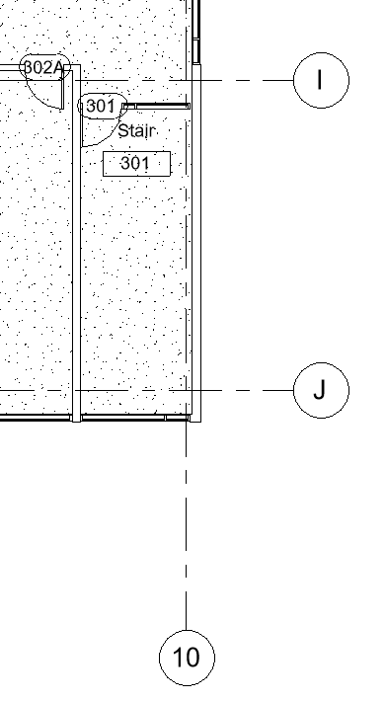

- Save project as per project requirements and Issue for Coordination
- Open the Staircase PIM stored in the Published
- Delete the staircase and create a new one using the dimensions as per the exhibit below:
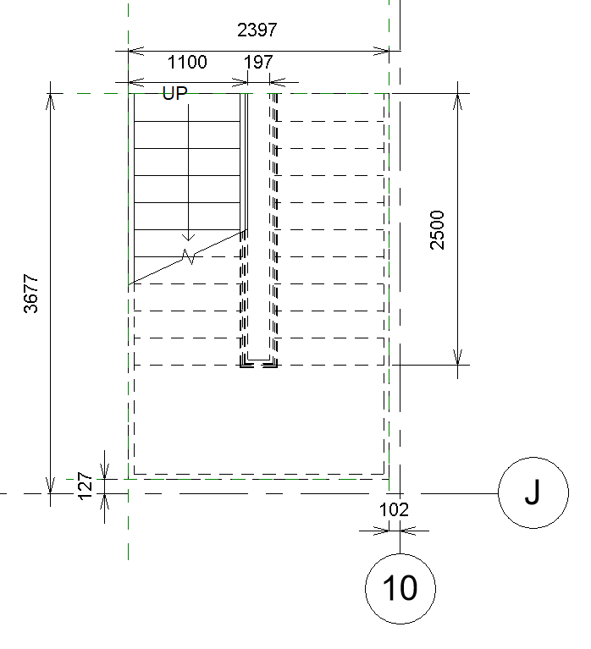
NB: Ensure the new stair makes use of the type 2 handrail on the inner side.

Task 6: Drawing Production Task E1.0

- Open the Volume 2 Architectural project created in Task B

- Produce dimensioned Floor Plan drawings @1:100 of Level00 on the provided A1 WSUK Template sheet

Make use of Crop View and other tools to ensure all drawings are produced to a professional standard
NB: Ensure the view name and scale are shown

- Produce the following Elevations of the model @1:100 on the provided A1 WSUK Sheet
- East
- South
- West

NB: Make use of Crop View and other tools to ensure all drawings are produced to a professional standard, and ensure the view name and scale are shown

- Name all drawings as per project requirements

USE OF COMPUTER:

Use of the computer is allowed from the beginning of the competition time.

OUTPUT:

- Software Modelled Structural Project Information Model Volume 2
- Software Modelled Architectural Project Information Model Volume 2
- Federated model as per BEP
- Assign Quality Assurance Issues (6 off)
- Corrected Structural Project Information Model Volume 1
- Corrected Staircase Information Model
- Corrected Architectural Project Information Model Volume 1
- COBie Data
- 1 (one) x Elevation drawing on A1 sheet uploaded to CDE.
  - Volume 2
- 1 (one) x Floor Plan drawing on A1 sheet uploaded to CDE.
  - Volume 2
- 1 (one) x External Render (.PNG)
- 1 (one) x Internal Render (.PNG)
- 1 (one) x 360º Rende
NOTES:

- All work must be completed within the 5 hour competition time and meet the deliverables deadlines as specified in the BEP.
- Information missing from the provided drawings is to be completed at the competitor’s discretion.
- All files are to be appropriately named and saved to the correct directory on the CDE as specified in the BEP as per BS EN ISO19650-1

Marking guidelines
Total marks available is 100 and is broken down into the following objective marks.
Objective marks as follows:

Aspect | Max Mark
Structural Modelling | 20.00
Architectural Modelling | 40.00
Coordination | 20.00
Corrective Architectural Modelling | 12.00
Drawing Production | 8.00
Total Marks | 100.00

Guide to Marks: National Finals

The marking scheme is designed to fairly compare every competitor’s work.

The marking is split between specific judgement aspects throughout the task, including efficiency, knowledge and technical performance.

The judges’ decisions will be independently moderated, and quality assured before being confirmed at the closing ceremony where the results are announced.

The judges are briefed on assessment procedures prior to the competition. Judges are looking for technical competency but are also briefed to look for excellence amongst competitors. Judges will therefore consider skills such as time management, working under pressure and communication skills. All marking is objective and based on agreed criteria.

The tasks for 2023 are in the final stages of development and will follow a similar format to those at the qualifiers but of a more complex nature, requiring an in-depth knowledge of current BIM standards, Architectural as well as Structural modelling, coordination, drawing production and visualisation.

All competitors will receive feedback after the competition on their performance

The allocation of marks is dependent on the tasks chosen and their complexity. Below is a broad outline of how marks may be distributed:

Aspect | Max Mark
Structural Modelling | 20.00
Architectural Modelling | 40.00
Coordination | 20.00
Corrective Architectural Modelling | 12.00
Drawing Production | 8.00
Total Marks | 100.00

Digital Resources

Below are some links to resources that might be of benefit to you in helping to prepare for the competition.

https://www.youtube.com/playlist?list=PLy_xtqs-1ccuBP82n-TNwcvue0-KWweC8
https://drive.google.com/drive/folders/1Y7E6elQV-LfOzBVtYhnCbq97xfWXchsV?usp=sharing

https://learn.supplychainschool.co.uk/local/tlactionplans/resources.php?formats=e-learning%20module
https://www.nationalbimlibrary.com/en-gb/
https://toolkit.thenbs.com/
http://www.wrap.org.uk/sites/files/wrap/Resource%20efficiency%20through%20BIM%20-%20a%20Guide%20for%20BIM%20Users.pdf
https://www.scottishfuturestrust.org.uk/storage/uploads/pathfindersreportfinaljuly2017.pdf
http://buildz.blogspot.com/

Judges Top Tips
Below are 5 tips from the judges of the BIM Competitions, in order to advise you on how to prepare for and succeed in the competition.

- Publish latest! If you don’t publish latest, we can’t see what you have modelled
- Remember to begin a new project with a template, never open a revit template (you can’t collaborate a template)
- Always pay attention to which folder you are asked to work in (WIP, Shared etc)
- Practice working to a BIM Execution Plan so you don’t waste time during the competition trying to figure it out
- Practice one or two small tasks and try to beat your own time or score several times

Source: https://www.goconstruct.org/construction-careers/what-jobs-are-right-for-me/bim-technician/

